Vivian Angwenyi, Arseny Alenichev, Cheick Sidibe, Alberto Garcia-Basteiro
[Dirección de correo electrónico]
Transglobal Health PhD Program. “The 3rd generation”


Case Study Revision assignment
Based on the original article: “Acceptability of impregnated school uniforms for dengue control in Thailand: a mixed methods approach inter and transdisciplinary research methods

Content
Background 2
Research aim 2
Research objectives 2
Study design 3
Study population 3
Data collection 3

Background

Impregnated school uniforms might be a valuable tool for dengue control.[1,2]. The coverage of this intervention could potentially be high since school uniforms are widely used in many settings. There is an ongoing randomized clinical trial in Thailand assessing the effectiveness of ISU in 2000 school children aged 7 to 18.[3] The study has terminated in July 2015 although results have not been published yet.

A crucial research gap for a wider implementation of this strategy (provided it is successful) is the acceptability by children, families, and other relevant members of the community. Concerns on its use could unable its potential as dengue control tool. An acceptability study with a mix methods approach was conducted among parents, teachers and principals of 321 school children who participated in the large RCT in Thailand.[4] It concluded that the acceptability of ISU was high although some concerns existed about the willingness to pay the additional costs for the ISU compared to the normal uniform. Although this was a relevant undertaking, there are some concerns on the methodology used, the representativeness and analysis of key stakeholders, the exhaustiveness of the research question, as well as on the generalizability of the conclusions.

Thus, we present a revised methodology that would analyse the acceptability of ISUs in a more comprehensive manner, with the involvement of all relevant stakeholders. We hope the proposed project will address most of the knowledge gaps regarding acceptability of ISUs as well as shed some light on the existing stakeholder networks involved in dengue prevention.

Research aim
Assess the knowledge and acceptability of the implementation of ISU as a Dengue control tool in School children; a study in different endemic regions in Thailand

Research objectives

- To explore the knowledge and understanding of dengue control measure among different stakeholders
- To map out the different stakeholders involved in Dengue Control and their engagement in the design of new Dengue Control tools in Thailand
- To investigate acceptability of implementing ISU in different Dengue endemic regions (RCT and non-RCT sites)
- To develop a mechanism of engagement among stakeholders for uptake of other pre-existing Dengue control tools in Thailand
- To follow-up the extent of ISU implementation within the health care system

Study design
Mixed methods study;
- Quantitative methods to include pre-post surveys to assess acceptability of ISU before/during the intervention and after the results/end of trial.
- Qualitative methods to include stakeholder mapping, FGDs and in-depth interviews, observations during informal and formal discussions, community maps/trend lines.

In order to come up with the improved design, we conducted a visual map of the context (who, where, when, how and why) and intervention. It can be found in Appendix B.

The following flowchart (figure 1) depicts the key stakeholders and their interactions in the research cycle.
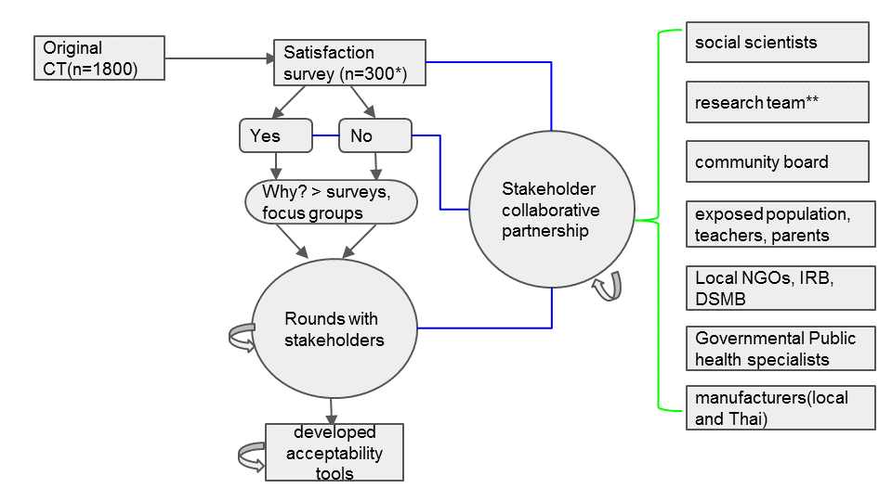

Study population
The proposed study will include the following target population. Children, parents, teachers, local manufacturers, government officials, community boards. Other relevant stakeholders will also participate in the overall design of the project as depicted in figure 1.

Sampling procedure
RCT participants will be randomly selected from RCT database. Non RCT participants (50% of the total study size) will be selected stratified by region, dengue endemicity). The final sample size will be based on a) proportion of parents that showed good acceptance of the intervention according to the study by Murray et al, a precision of 10% with 95% CI, and a response rate of 90%. A statistician will finalize sample size estimates.

Data collection
Overall, data collection will be based on an iterative process, and every iteration will provide additional knowledge that will be utilized to refine the research process. For the quantitative approach, we will use a survey based tool that will be paper based, back translated (English Thai English) and piloted amongst a few participants. There will be a survey after the RCT results are available and provided to study participants, which will assess whether the results of the RCT might influence the acceptability of ISU’s among participants. The qualitative part of the research will use interview guides with key themes of the study question. During FDGs we will use visual aids. This process will be audio recorded.

SH analysis
A map out stakeholders and their roles will be conducted prior to the study initiation. The study team will also get feedback of the issues to explore in our tool as described in figure 1. A preliminary stakeholder analysis was conducted following a policy and implementation grid. It is shown in appendix A.

Data management and analysis
Data will be double entered by data clerks and introduced in an electronic database (Openclinica Software). Preliminary results will be discussed within the research team and shared with the study participants. Qualitative analysis will be done using Nvivo software. Quantitative analysis will be done using R statistical package.

Ethical considerations
It is planned to create Informed consent for parents, in Thai language. It will be essential to keep in mind a possibility of illiteracy of a participant, in this case it would be necessary to involve stakeholder who would be able to deliver information from the IC form. For children it is planned to implement minor assent form. This research presents no more than a minimal risk, as by the definition of OHRP. Monetary compensation for research subjects will be acknowledged with community members to prevent persuasion to participate.
The main benefit from participation is an access to innovative preventive approach. Additionally, participation will contribute to society by gaining evidence-based data which could be utilized in the future. Research protocol will fit local, national and international regulations. For the backbone of the project it is intended to implement benchmarks of international research by Emmanuel and colleagues:
(1) value—enhancements of health or knowledge must be derived from the research; (2) scientific validity—the research must be methodologically rigorous; (3) fair subject selection—scientific objectives, not vulnerability or privilege, and the potential for and distribution of risks and benefits, should determine communities selected as study sites and the inclusion criteria for individual subjects; (4) favorable risk-benefit ratio—within the context of standard clinical practice and the research protocol, risks must be minimized, potential benefits enhanced, and the potential benefits to individuals and knowledge gained for society must outweigh the risks; (5) independent review—unaffiliated individuals must review the research and approve, amend, or terminate it; (6) informed consent—individuals should be informed about the research and provide their voluntary consent; and (7) respect for enrolled subjects—subjects should have their privacy protected, the opportunity to withdraw, and their well-being monitored.[5]
It is planned to submit research protocol and all corresponding documents (including recruitment advertisements) to IRBs at: Research cite and 2) Institutions to which researchers are affiliated. Special attention would be paid to voluntary nature of this research and opportunity for participants to opt-out from the research at any stage.

Timeline
 | 2015 |  |  |  | 2016
 | S | O | N | D | J | F | M | A | M | J | J | A | S | O | N | D
Final Protocol Writing
VU ICC Submission
VU and Thai IRB Submission
Preparation of research tools
Research team training
Eletronic CRFs Design
Kick Off Meeting
Data Collection / Recruitment
Analytical Plan Design
Data Analysis
Manuscript writing
Dissemination of Results

Study limitations
To be acknowledged.

Appendix A

Stakeholders | Stake of interest | Resources | Action channels | Probability of participation | Degree of influence
Supporters
Government officials I.E. | Health Promotion | Financial; Human resources; Networking; Policy making; | Policy making influence | High | High
International manufacturers | Product development; Financial | Product _Uniforms | Supply of innovative product; Funding | High | High
Community boards _religious leaders; local administration; civil society groups | Gatekeeping | Custodians of local knowledge and culture | Direct contact with potential participants | High | High

Schools and teachers | Education and well being | Educational resources; intervention target group | Consumers | High | High
Parents and community | Wellbeing | Legal custodians of children | Consumers | High | High
Children | Wellbeing | Target group | Consumers | High | High

Local based NGOs or CBOs | Health Promotion | Financial; Networking; Hunan Resources; Expertise | Mobilisation | High | High
Neutral
Clinical trial investigators_ epidemiologist; statisticians; health economics; clinicians; nurses; entomologist; public health | Research | Human Resource; Technical; Intellectual | Knowledge generation | High | Medium
Social Science Investigators | Adoption of scientific knowledge; mediators | Intellectual | Knowledge production | High | Medium
IRBs and DSMBs

Opposers
Local manufacturers | Creation of a generic product_uniforms | Bulk material | Supply of generic product | Medium | High

Appendix B
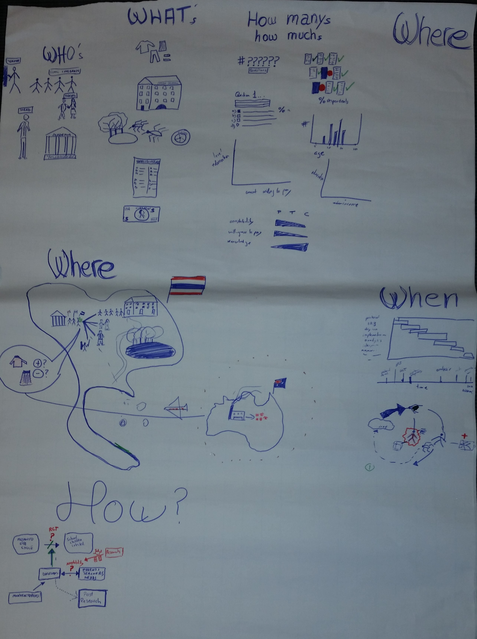
Figure 2. Visual map of the context (who, where, when, how and why) and intervention preliminary analysis.

References
1. Massad E, Amaku M, Coutinho FAB, Kittayapong P, Wilder-Smith A. Theoretical impact of insecticide-impregnated school uniforms on dengue incidence in Thai children. Glob. Health Action 2013; 6:20473.
2. Londono-Renteria B, Patel J, Vaughn M, et al. Long-Lasting Permethrin-Impregnated Clothing Protects Against Mosquito Bites in Outdoor Workers. Am. J. Trop. Med. Hyg. 2015;
3. Wilder-Smith A, Byass P, Olanratmanee P, et al. The impact of insecticide-treated school uniforms on dengue infections in school-aged children: study protocol for a randomised controlled trial in Thailand. Trials 2012; 13:212.
4. Murray N, Jansarikij S, Olanratmanee P, et al. Acceptability of impregnated school uniforms for dengue control in Thailand: a mixed methods approach. Glob. Health Action 2014; 7:24887.
5. Emanuel EJ, Wendler D, Killen J, Grady C. What makes clinical research in developing countries ethical? The benchmarks of ethical research. J. Infect. Dis. 2004; 189:930–7.

